GREENTECH ANALYTICS
Modular Assignment 1| Introduction to Cloud Computing
Md Habib Ahmed | IHC – Cloud Development | October 2026

1. Objective and scope
GreenTech Analytics requires a sustainable, web-accessible service that combines live environmental observations with historical climate information. I implemented a small serverless prototype on two cloud providers: AWS Lambda in Stockholm (eu-north-1) and Azure Functions in Central India. Each endpoint retrieves current weather for Abha, Saudi Arabia, reads a historical temperature dataset, computes a long-term average, and returns a consistent JSON response. The comparison focuses on practical deployment, response time, elasticity, cost, and security rather than claiming that either platform is universally faster.

2. Applying the NIST cloud model
The implementation illustrates the five NIST essential characteristics. On-demand self-service appears in console-based provisioning without requesting physical servers. Broad network access is provided by HTTPS endpoints callable from ordinary clients. Resource pooling comes from provider-managed infrastructure shared across tenants. Rapid elasticity is demonstrated by handling concurrent requests without manually adding servers; this is evidence of concurrent execution, not a complete capacity-limit test. Measured service is represented by AWS CloudWatch and Azure Application Insights invocation and duration metrics. Lambda and Functions are function-as-a-service implementations within a serverless PaaS model; the exposed API is a usable service, although not a full SaaS application.

3. Architecture and data flow
A browser or test client invokes either HTTP endpoint. The function calls OpenWeatherMap over HTTPS for live temperature and humidity, loads an Abha-filtered Kaggle Earth Surface Temperature CSV from Amazon S3 or Azure Blob Storage, and calculates the historical mean and the difference from the live reading. AWS CloudWatch and Azure Application Insights capture operational telemetry. Both implementations return the same logical JSON structure, allowing direct functional comparison despite using different programming languages and regions.
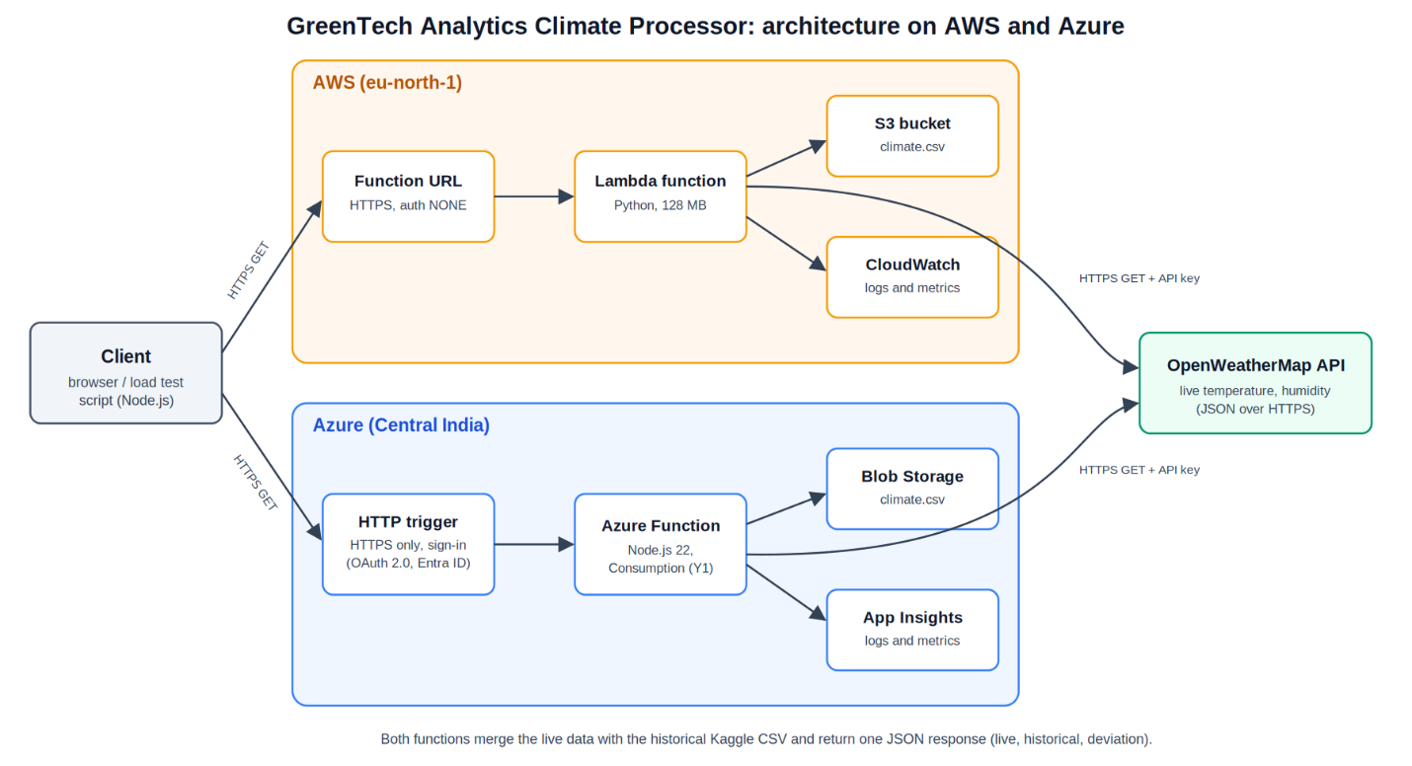
Figure 1. Equivalent AWS and Azure processing paths and monitoring services.

4. Deployment and implementation
On AWS, I deployed Python to Lambda with 128 MB memory and a 15-second timeout. An HTTPS Lambda Function URL used NONE authentication during testing; the execution role had S3 read access. On Azure, I deployed a Node.js 22 HTTP-triggered function on a Windows Consumption (Y1) plan and stored the CSV in Blob Storage. Secrets and connection settings were placed in environment or application settings rather than hardcoded in application code. The Azure free-trial account imposed region and plan restrictions, so Node.js was used instead of the initially preferred Python runtime. An Application Insights workspace also required manual setup. AWS deployment was more straightforward in this experiment.
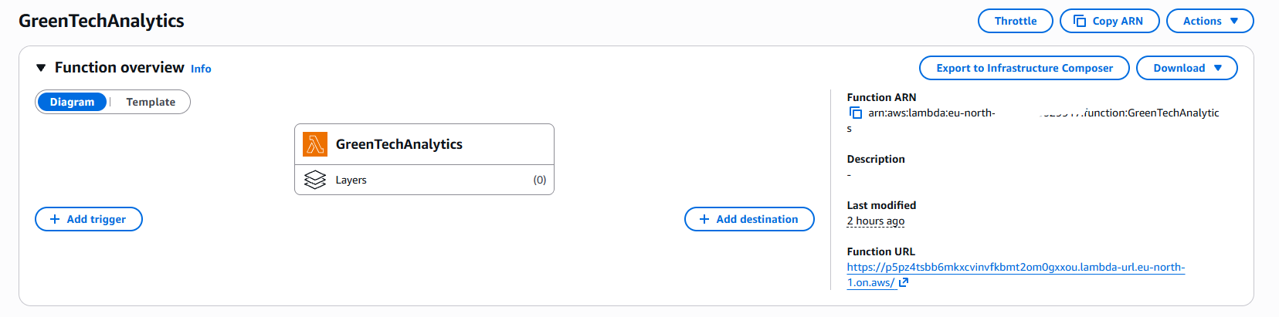
Figure 2. AWS Lambda deployment overview.

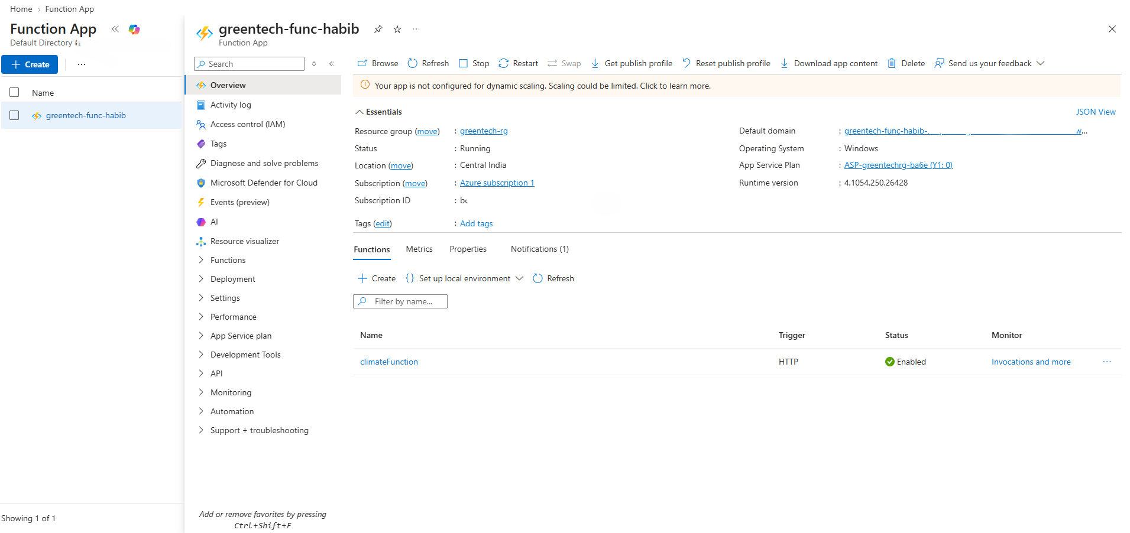
Figure 3. Azure Function deployment overview.

5. Dataset integration and output validation
The first data source was the OpenWeatherMap current-weather API, which returns live observations in JSON. The second was a Kaggle Earth Surface Temperature CSV filtered to Abha and uploaded to both cloud storage services. The historical subset contained 1,825 records spanning 1861–2013, with a calculated mean temperature of 24.48 °C. Both cloud responses reported matching historical record counts and averages, supporting functional equivalence. The selected historical file did not contain a CO₂ field, so the prototype does not claim to process CO₂ measurements. This is a dataset limitation, not a missing calculation hidden by the report.
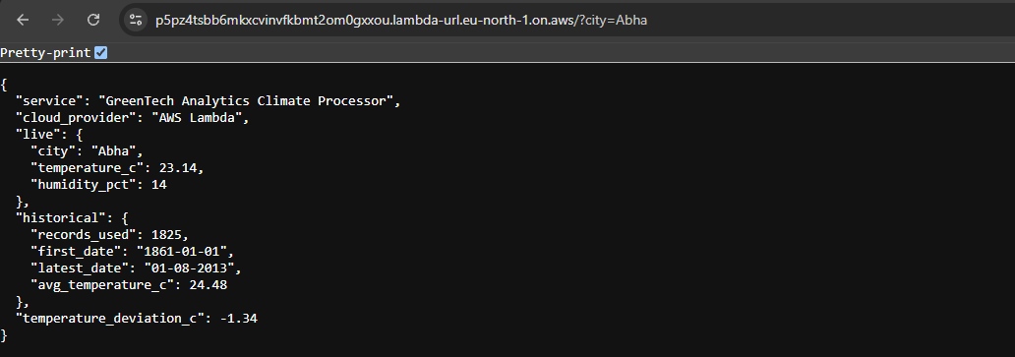
Figure 4. AWS endpoint returning the merged climate JSON.
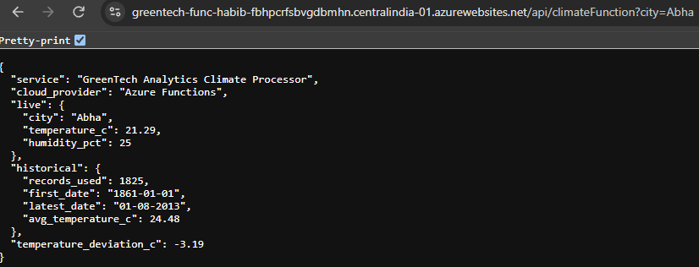
Figure 5. Azure endpoint returning the equivalent JSON before sign-in was enabled.

6. Load testing and measured performance
A Node.js load-test script sent 50 requests per endpoint with concurrency of 10. Two runs were recorded for each provider; the first could include cold-start overhead. Tests originated from my workstation, while AWS ran in Stockholm and Azure in Central India, so regional network distance affects observed latency. All four scripted runs recorded zero request errors. The figures below are measurements from this limited test, not provider-wide performance benchmarks.
Metric | AWS run 1 | AWS run 2 | Azure run 1 | Azure run 2
Average | 642 ms | 504 ms | 2,928 ms | 360 ms
Median | 339 ms | 348 ms | 186 ms | 208 ms
Slowest | 2,201 ms | 1,057 ms | 16,217 ms | 2,292 ms
Errors | 0 | 0 | 0 | 0
CloudWatch recorded 10 concurrent Lambda executions and durations ranging from 181 ms to 777 ms, averaging 351 ms in the observed view. Azure Application Insights showed 101 successful and two failed invocations overall, although the scripted tests reported no errors; the cause of the two portal failures was not established. Azure had the longest first-run request (about 16 seconds), while its warm-run median was lower than AWS in this particular environment. The evidence supports automatic serverless concurrency, but does not prove maximum scaling capacity or identical network conditions.
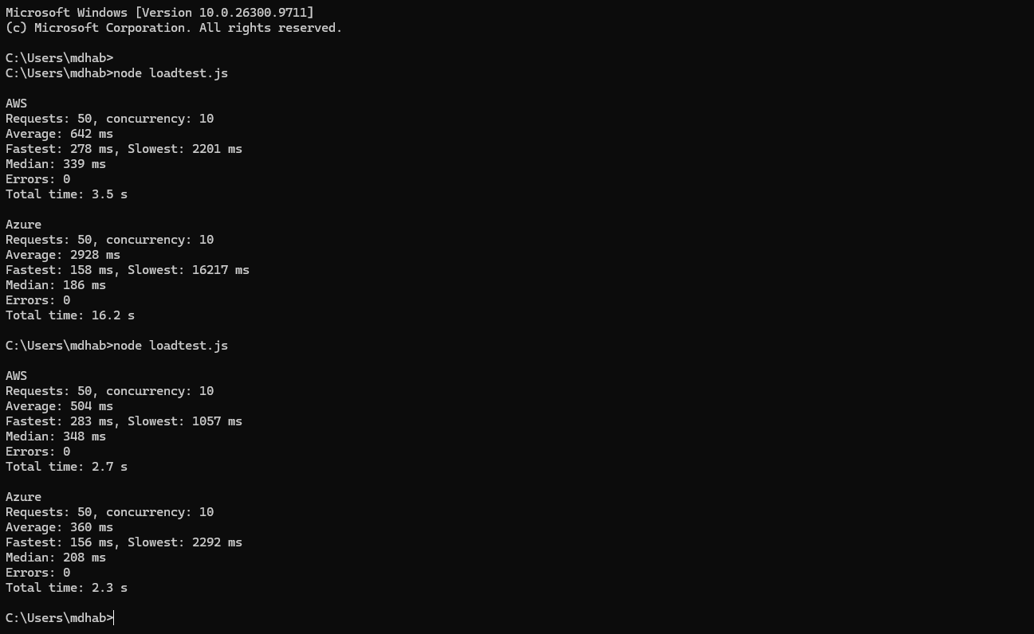
Figure 6. Client-side comparative load-test output.

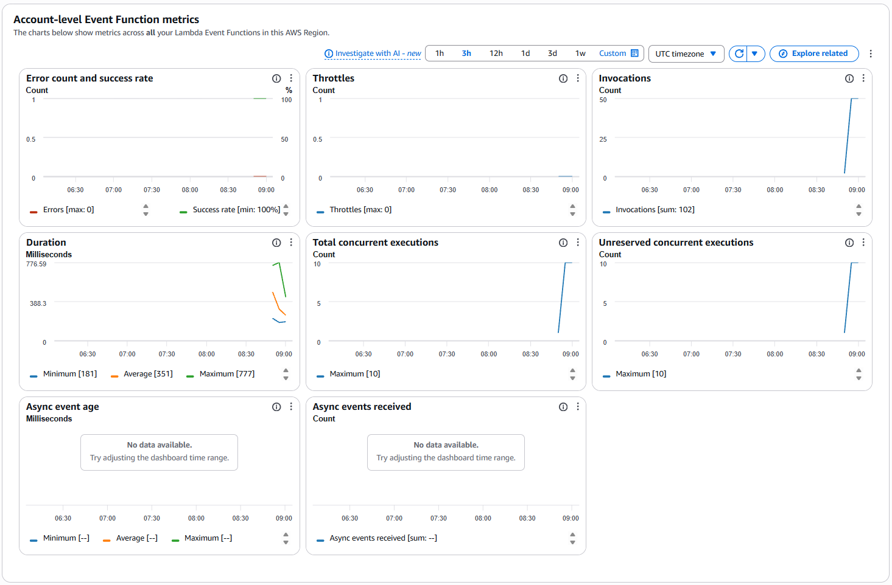
Figure 7. AWS CloudWatch execution and duration metrics.

7. Security, costs, and operational trade-offs
Both services used HTTPS and JSON over REST-style endpoints. Azure HTTPS-only enforcement was enabled, and Microsoft Entra ID sign-in using OAuth 2.0/OpenID Connect was added after the unauthenticated JSON test; subsequent access requires sign-in. The AWS Function URL remained publicly callable during testing, and its role also had PowerUserAccess beyond the narrower S3 permission. A production version should enforce least-privilege IAM, protect the AWS endpoint with appropriate authentication, and restrict secret exposure. Environment variables improve code hygiene but should be supplemented by managed secret storage where practical.
At this small workload, observed charges were negligible: Azure displayed $0.00 and AWS still showed $120.00 of promotional credit remaining. Remaining credit is not the same as measured service cost, so this evidence cannot establish a precise AWS-versus-Azure price difference. AWS was easier to configure; Azure offered a lower warm median in the recorded tests but required additional account-specific setup. Costs at production scale would depend on request volume, execution time, memory allocation, storage, network traffic, and monitoring.
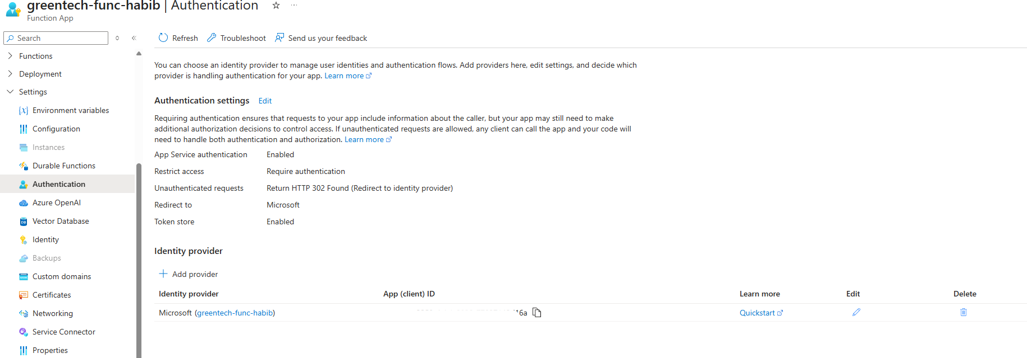
Figure 8. Azure built-in authentication configuration.

8. Conclusion and reproducibility
The prototype met its central goal: two independently deployed cloud functions combined live weather with the same historical temperature records and returned equivalent results. The exercise demonstrated serverless deployment, basic elasticity, monitoring, API integration, and practical cloud-provider differences. Its principal limits are the absent CO₂ data, small load-test sample, unmatched cloud regions, and incomplete production-grade AWS access controls. The source repository includes implementation and setup guidance; archived screenshots document deployment even if an endpoint is no longer available.
Repository: https://github.com/mdhabibhameedi/greentech-climate-processor
API documentation: OpenWeatherMap current weather API (live JSON); Kaggle Earth Surface Temperature dataset (historical CSV). Deployment endpoints: refer to the repository documentation; live availability is not guaranteed.

